3) Develop a flowchart in Figma depicting the operation of a Network Switching Subsystem in a mobile cellular system.
1. Aim
To develop a flowchart in Figma illustrating the operation of the Network Switching Subsystem (NSS) in a mobile cellular system, showing call processing, subscriber authentication, call routing, and connection termination.
2. Software Used
- Figma: Online UI/UX and flowchart design tool.
- Web Browser: Google Chrome.
- Internet Connection: For accessing Figma.
3. Procedure
- Open the Figma website (https://www.figma.com).
- Log in to your Figma account and create a new design file.
- Select the Frame tool and create a suitable workspace.
- Add a title: "Network Switching Subsystem in Mobile Cellular System".
- Use rectangles to represent processing steps.
- Use diamonds to represent decision-making operations.
- Use arrows to connect all the steps in the correct sequence.
- Add labels, colors, and icons to improve the design.
- Arrange all elements neatly and check the connections.
- Save and export the completed flowchart.
4. Prototype
The prototype represents the working process of the Network Switching Subsystem.
Main components:
- MSC (Mobile Switching Centre): Controls call switching and routing.
- HLR (Home Location Register): Stores permanent subscriber information.
- VLR (Visitor Location Register): Stores temporary subscriber information.
- AuC (Authentication Centre): Verifies subscriber identity.
- EIR (Equipment Identity Register): Checks mobile device identity.

5. Design
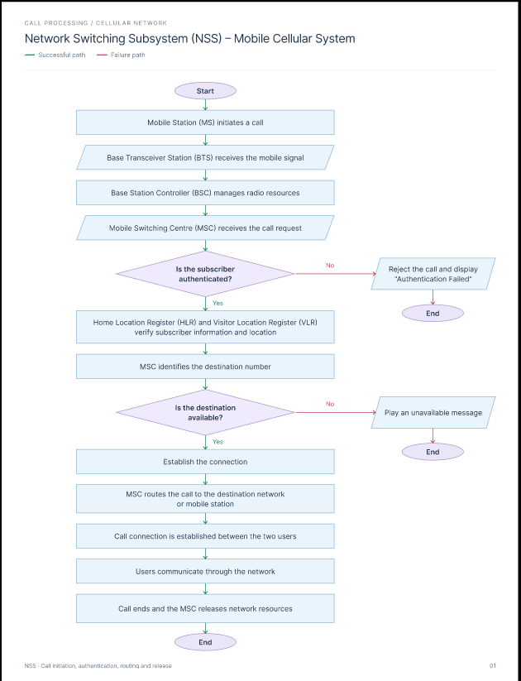

6. Result
Successfully developed a flowchart prototype in Figma representing the operation of the Network Switching Subsystem in a mobile cellular system. The design clearly illustrates subscriber authentication, call processing, routing, connection establishment, and call termination.

